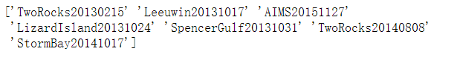 Appendix 1.1 TwoRocks2014 preprocessing

different gliders in the raw dataset

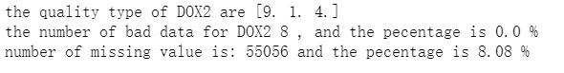

number and percentage of bad and missing data for DOX2

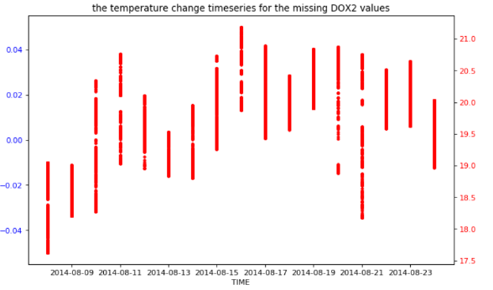

timeseries on the missing DOX2 values against temperature

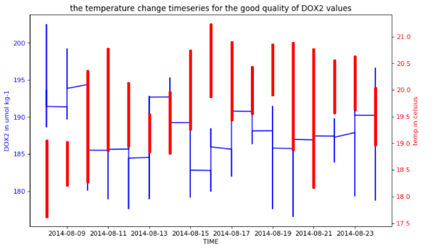

timeseries on the good type DOX2 values against temperature